Garrett Dunn

2/26/2022

CS 255

SNHU

# CS 255 System Design Document Template

## UML Diagrams

### UML Use Case Diagram

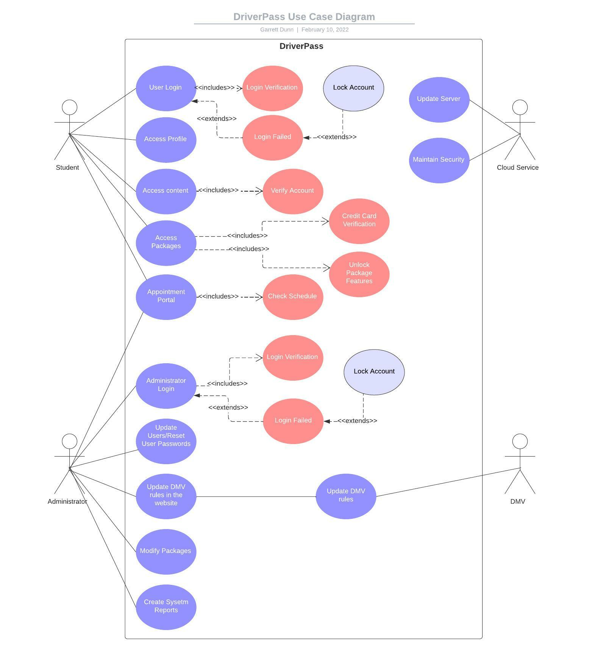

### UML Activity Diagrams

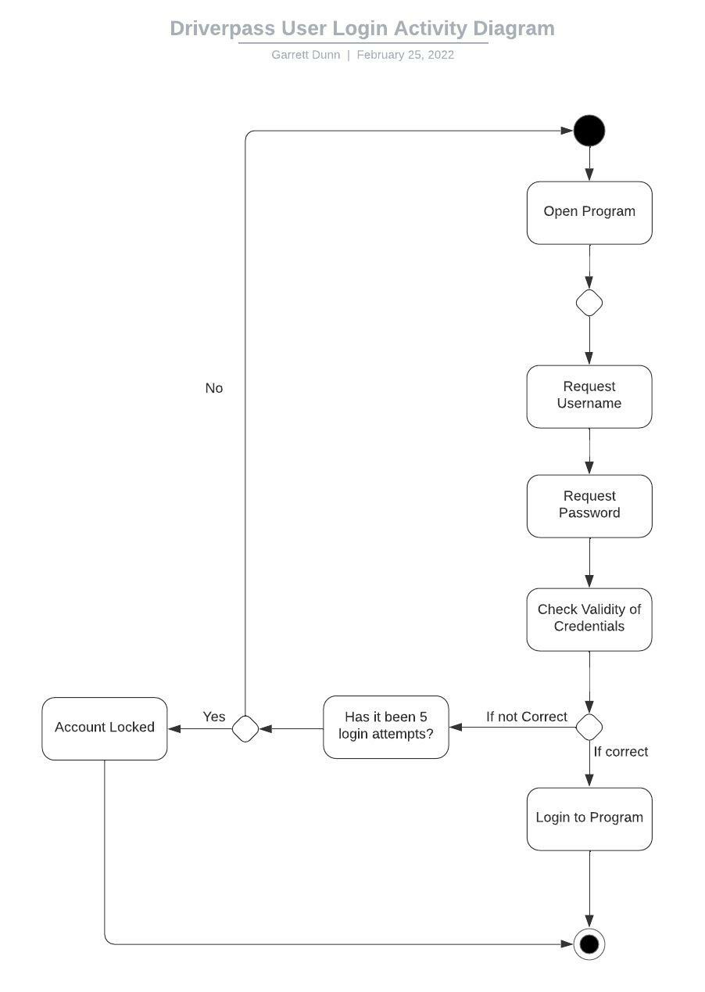

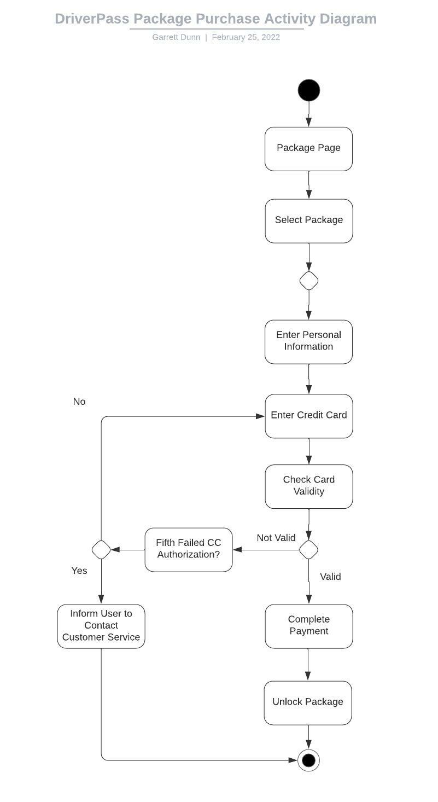

### UML Sequence Diagram

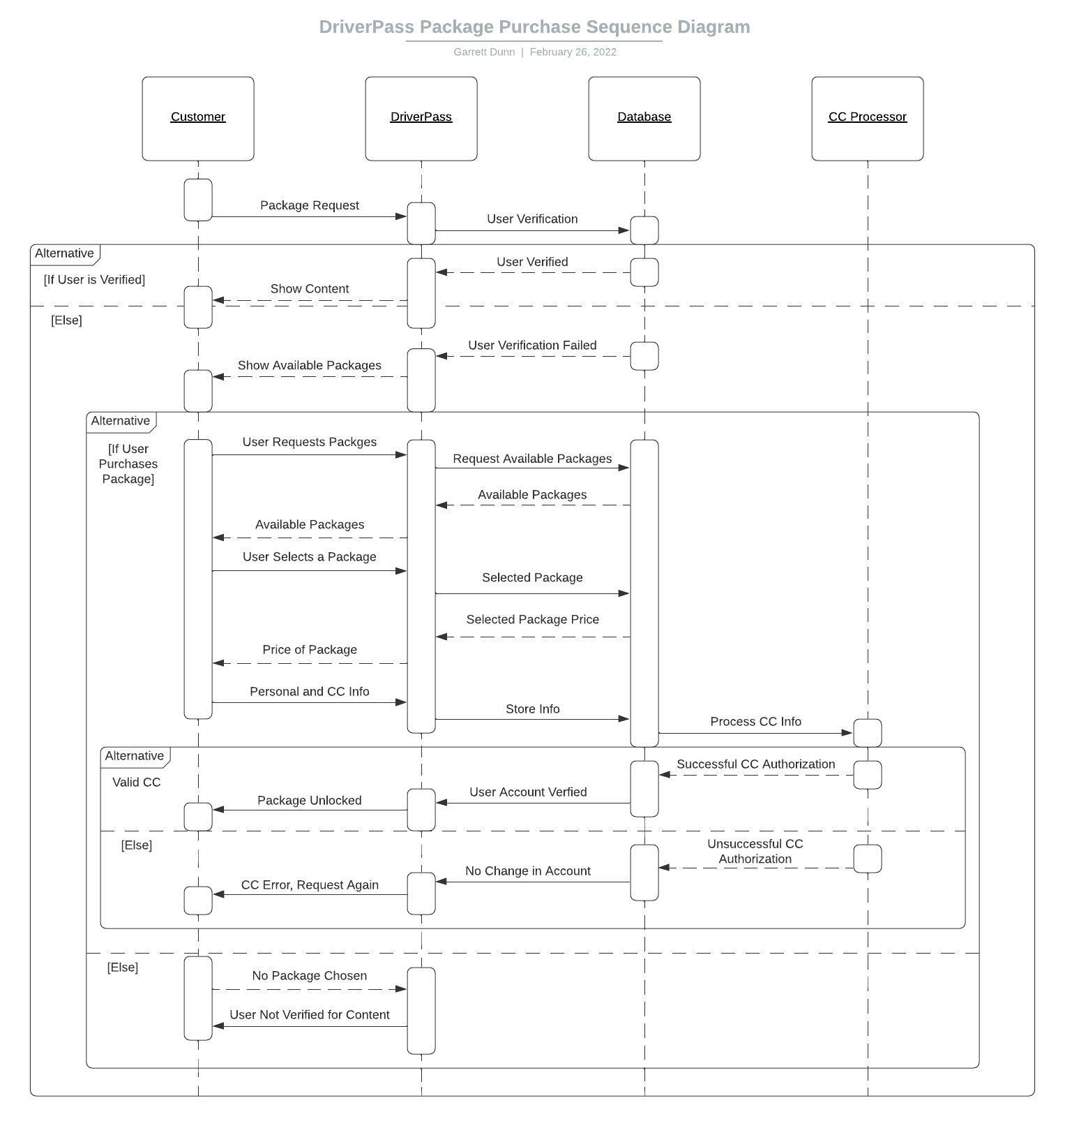

### UML Class Diagram

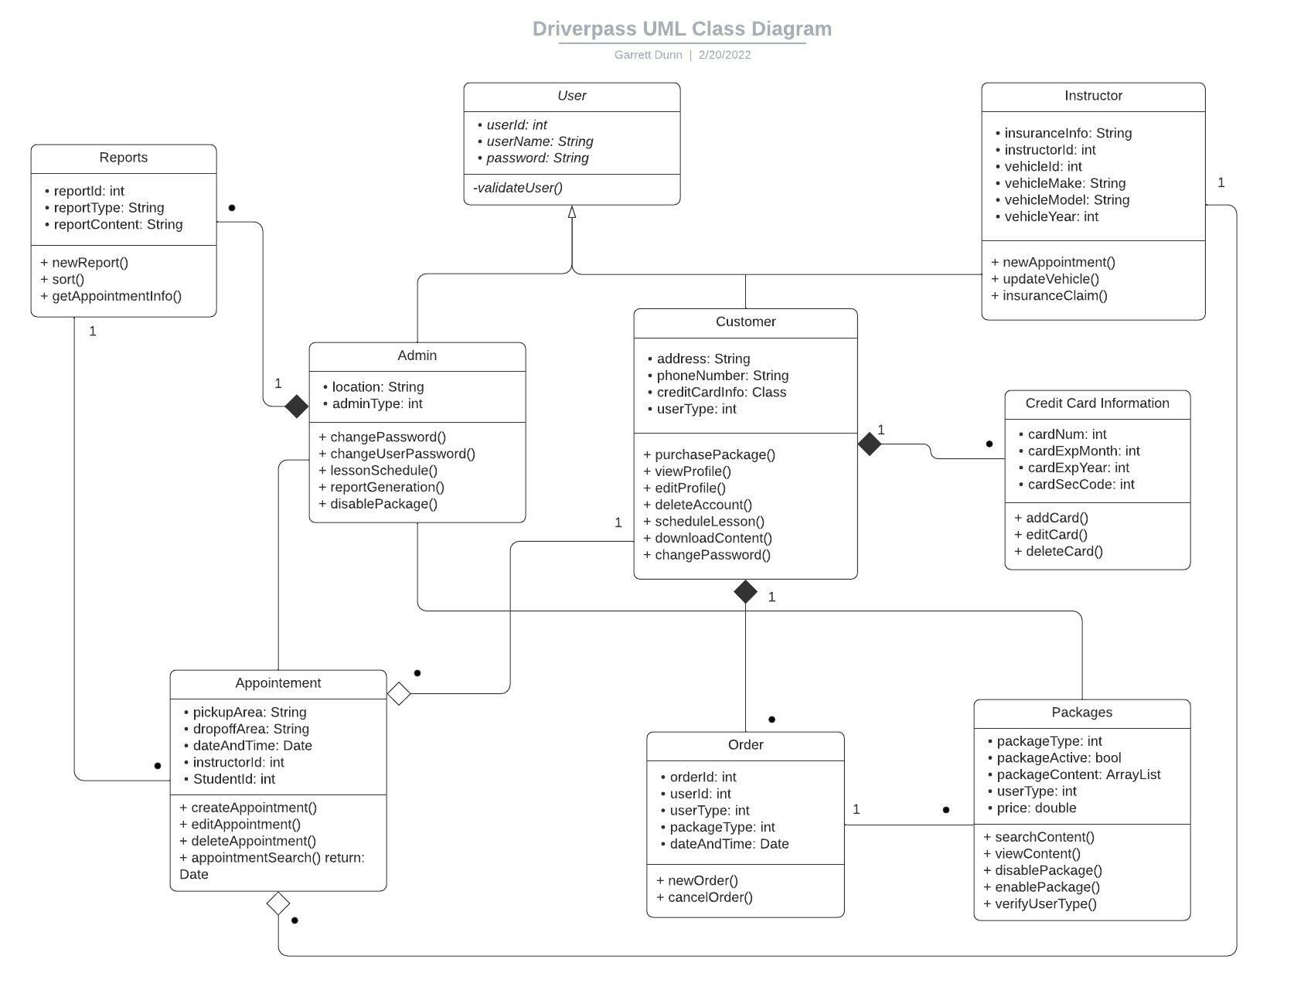

## Technical Requirements

*Host Hardware Requirements:*

* Source of power
* Internet
* At least one server
* Networking cables
* Computer peripherals

*Customer Hardware Requirements:*

* Source of power
* Internet
* A computer, laptop or desktop. If desktop, peripherals required
* WiFi card or ethernet cable

*Host Software Requirements:*

* Windows OS
* DriverPass software
* Security software

*Customer Software Requirements:*

* Operating system
* Web browser

*Development Tools:*

* Internet access
* Computer with development tools
* Network administrator tools
* Operating system (preferably Linux)

*Required Infrastructure:*

* Cloud provider
* Contract with CC processor
* Sufficient power and internet capabilities at office locations
* Vehicles for driving practice/tests
* Car insurance for all instruction test vehicles